

7.2.1: Describe two best practices successfully implemented by the Institution as per NAAC format provided in the Manual.
ADDITIONAL INFORMATION

Skill Will Club The Context:
Skill acquisition is the ability to the trained on a particular task or functions and become expert in it. To achieve the needs of present job market skill education is essential for graduate students / youth. So skill based education should be part of any teaching programme. Skill acquisition makes the students employable besides the obtaining of the degrees. For this purpose, initiative has been taken up and the curriculum also designed with the actual requirements of the job-market in mind and to create will among students for competing the job-market, equipped with the necessary soft-skills.

Objectives:
The programme aims to import soft-skills including communication skills, presentation skills. Personality Skills and Job-Skills help students to acquire General English Skills and help to remove mental blocks involved in communication. The skill will club aims to train students in soft-skills to empower them to compete in the job-market. Soft skills contribute to increasing the students’ performance and productivity at the workplace with excellent time management and communication skills. It helps the students to build a good relationship in one’s personal life and professional life.

The Practice:
The practice involves a group of teachers to voluntarily conduct classes and provide training to students. Teachers from the Department of English have designed the programme, and the programme will be held with the help of teachers from all faculties. Teachers put special efforts without remuneration besides the regular work. No fee is collected from the students for the purpose. The club identifies a large group of 30 students through simple test orientation programme conducted for the students to know the importance of the skill acquisition.
  - Theory classes Time: 25-30 hrs.
  - Students are equipped with the audio0 system, audio cassettes, cd’s and the course books, Cambridge series books for better understanding of pronunciation and to build conversational skills

A. English speaking practice:
- Audio versions of conversation.
- Phonetic pronunciation of vowels and consonant sounds.
- Listening tracks of 1 minute to learn the pronunciation and to find out the concept.
- Reading Practice: Text reading, news paper reading, reading aloud, poem recitation.

Writing:
  - Writing conversation for an imaginary context.
  - Letter writing practice
  - Report writing
- Group Discussion:
  - Involving teachers for practice and giving tips to the students for moderation in Group Discussion.
  - Playing video presentation of group discussion
  - Critical commentary and tips on GDs’.

Job Skills:
  - Giving instructions on Mock Interviews and conducting interviews.
  - Theory classes on interpersonal skills
  - Resume preparation
  - Practice on telephone etiquette

V A. Obstacles faced and strategies adopted.
- Students faced some technical issues at primary levels.
- Lack of exposure on phonetics in early academics.
- Internet connectivity problems.

B. Strategies:
- Oral practice of vowel and consonant sounds.
- Sharing audio and video versions to students’ android phones to self learning at the time of network connectivity problem.
- Engaging bring students to monitor the club activities.

Impact of the practice:
The impact of the programme is very good students developed self-confidence to overcome the stage fear to present and to give presentation, seminar, self introduction etc., A large number of students intend to join the programme and want to get the benefit of this voluntary initiative from the teachers.

Resources Required:
  - Cambridge series books
  - Audio-visual equipment
  - Suitable furniture for GDs, Mock interviews

Syllabus

LISTENING SKILLS
- Importance of listening
- Types of listening

- Barriers to listening
- Effective listening

SPEAKING SKILLS
- Sounds of English Introduction

- Theoritical concepts

- Word accent
- Intonation

READING SKILLS
- Skimming
- Scanning
- Intensive reading
- Extensive reading

WRITING SKILLS
- Punctuation
- Spelling
- Paragraph writing

- Letter writing

SOFT SKILLS
- Swoc analysis
- Interpersonal skills

- Group discussions

- Debates

- Interview skills

ATTENDANCE

S.NO | NAME OF THE STUDENT | GROUP | ATTENDANCE
1 | SHAIK RUQSAR | III MSCS | 20/30
2 | S.ZAKIYA TABASSUM | III MSCS | 21/30
3 | A.TEJA | III MSCS | 21/30

4 | S.AFRIN |  | III MSCS | 23/30
5 | B.ANUSHA |  | III MSCS | 24/30
6 | B.BHARGHAVI |  | III MSCS | 22/30
7 | A.CHARITHA |  | III MSCS | 27/30
8 | P BHAHESWARI |  | III BCOM CA | 22/30
9 | A SUKANYA |  | III BCOM CA | 23/30
10 | A GAYATRI |  | III BCOM CA | 25/30
11 | T PRIYANKA |  | III BCOM CA | 23/30
12 | P DIVYA |  | III BCOM CA | 18/30
13 | K NAGASASI |  | III BCOM CA | 21/30
14 | K RANI |  | III BCOM CA | 24/30
15 | R PRASANTHI |  | III BCOM CA | 22/30
16 | A V VASANTHA |  | III BA ADV | 20/30
17 | P SRUTHI |  | III BA ADV | 22/30
18 | G V SIREESHA |  | III BA ADV | 21/30
19 | C YAMINI |  | III BA ADV | 23/30
20 | M DIVYA |  | III BA ADV | 27/30
21 | E MUNEESWARI |  | III BA ADV | 28/30
22 | D SIREESHA |  | III BA ADV | 22/30
23 | N SRAVANI |  | III BA ADV | 29/30
24 | V S NAZVEEN |  | III BA ADV | 25/30
25 | Y MADHAVI LATHA |  | III BA ADV | 26/30
26 | P.NAJININ |  | III MSCS | 22/30
27 | B.LAKSHMI NANDANA |  | III MSCS | 21/30
28 | B.SUPRIYA |  | III MSCS | 25/30
29 | C.SIVA NAVITHAD.LAKSHMI DEVI |  | III MSCS | 26/30
30 | G.MOUNIKA |  | III MSCS | 22/30

GALLERY

  - GROUP DISCUSSION
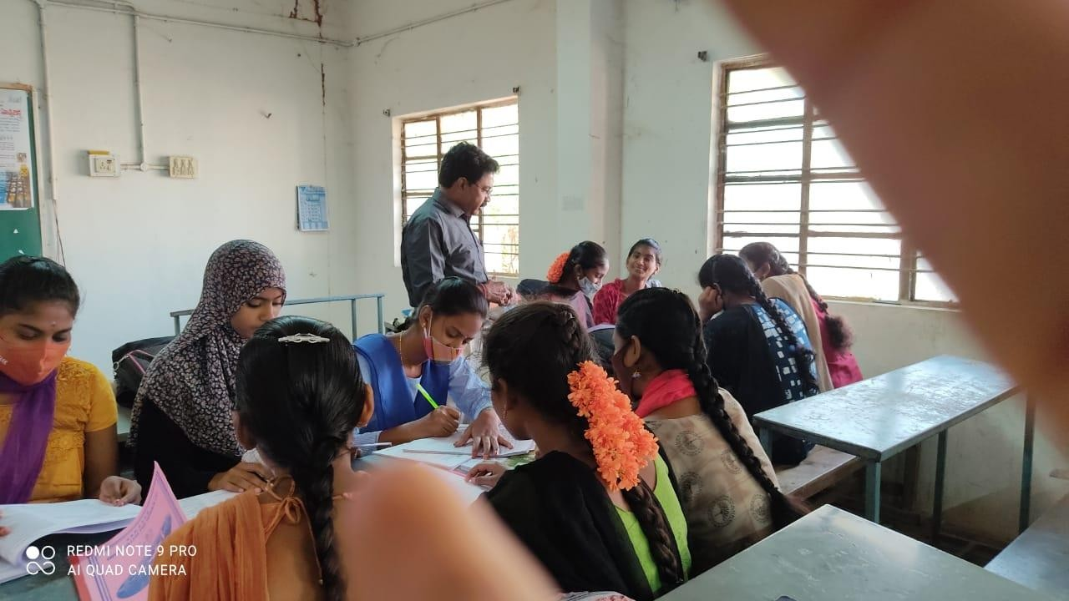
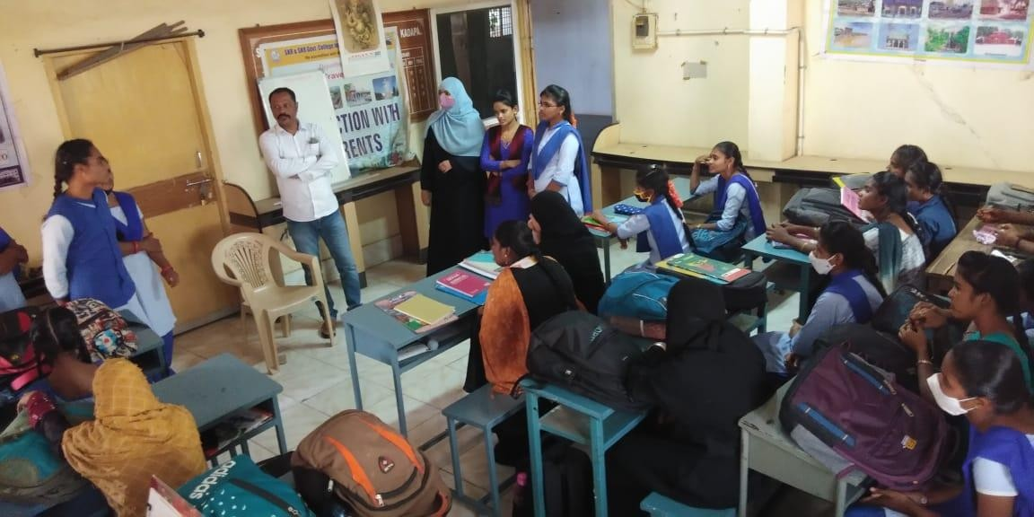

DIALOGUE BUILDING

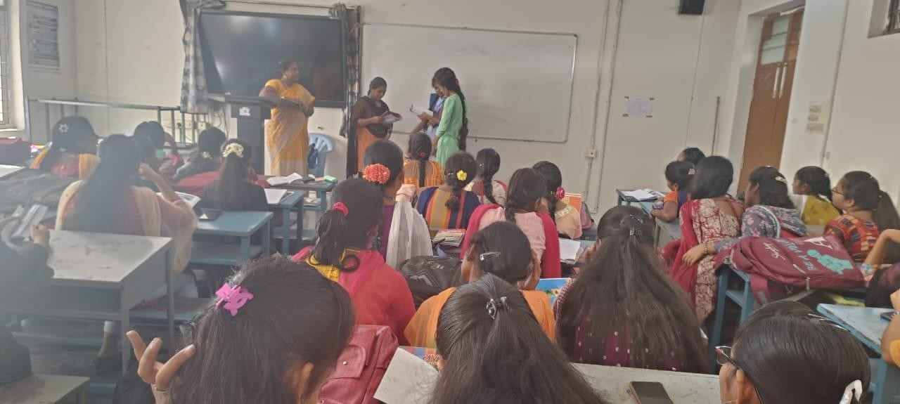
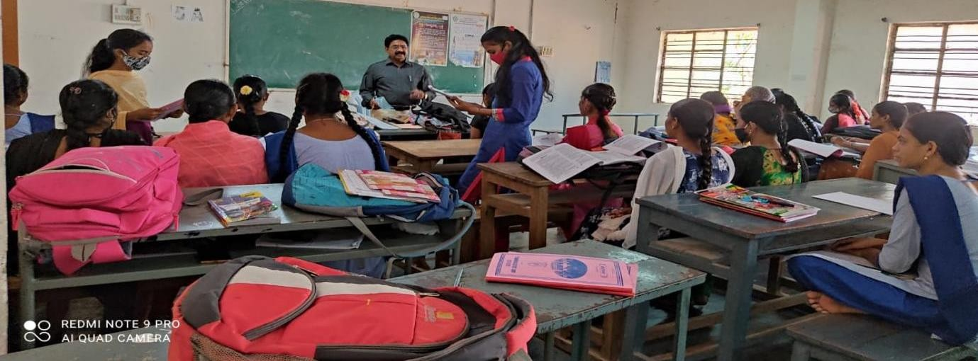

  - QUIZ
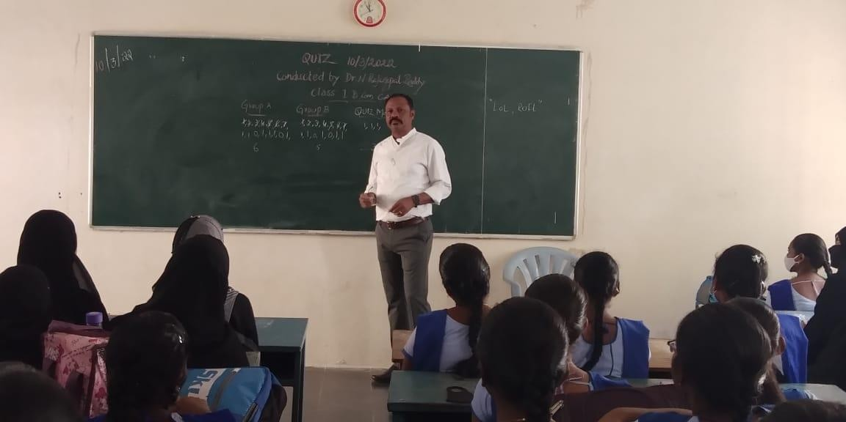

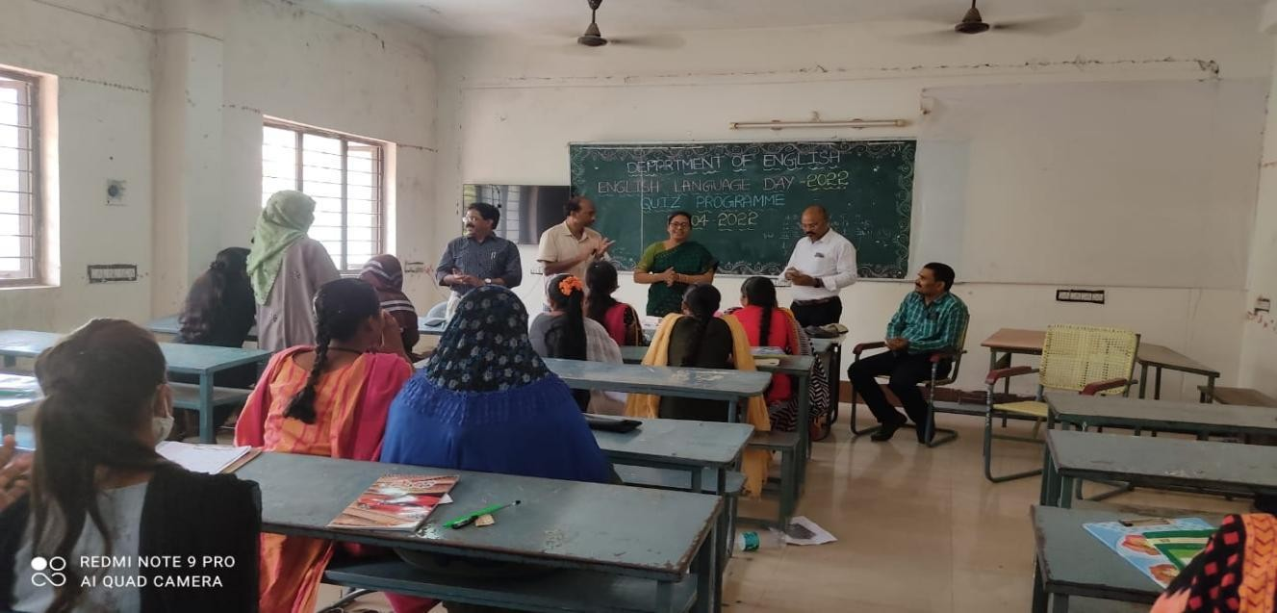
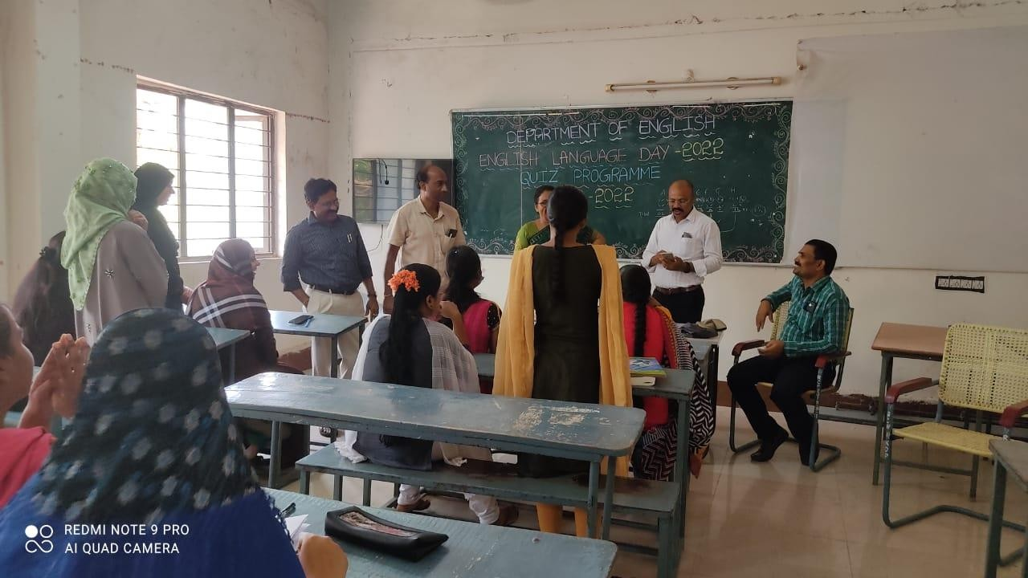

  - INTERVIEW SKILLS
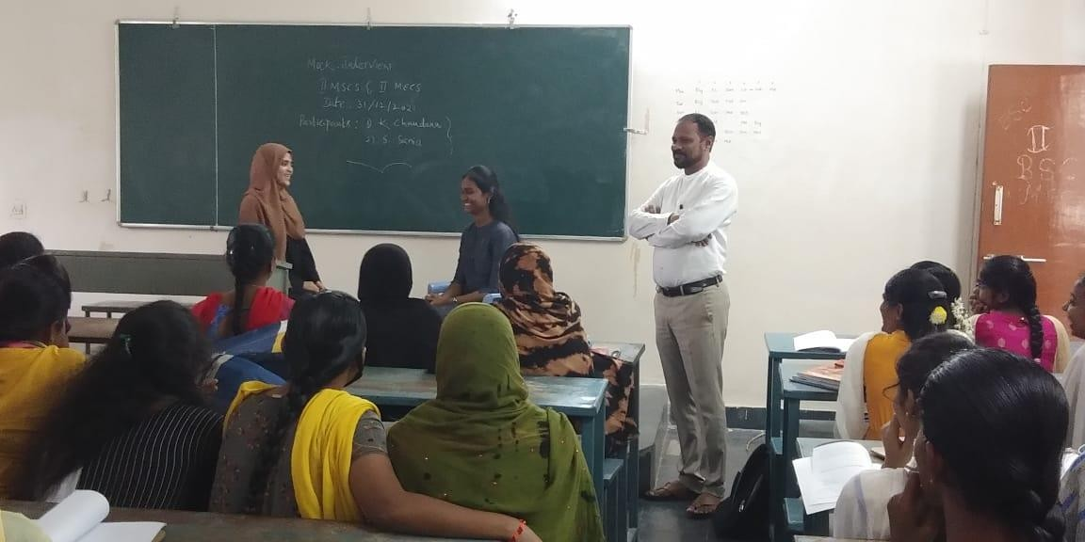

  - PLEASURE READING
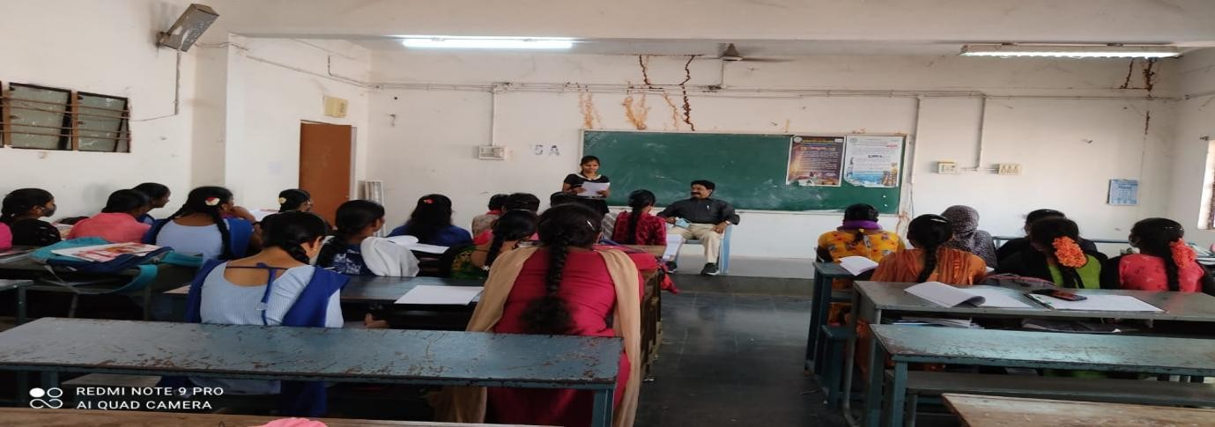
  - READING SKILLS
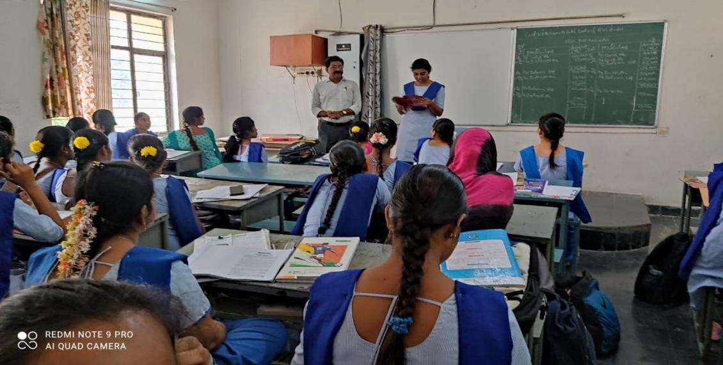

  - JAM SESSIONS
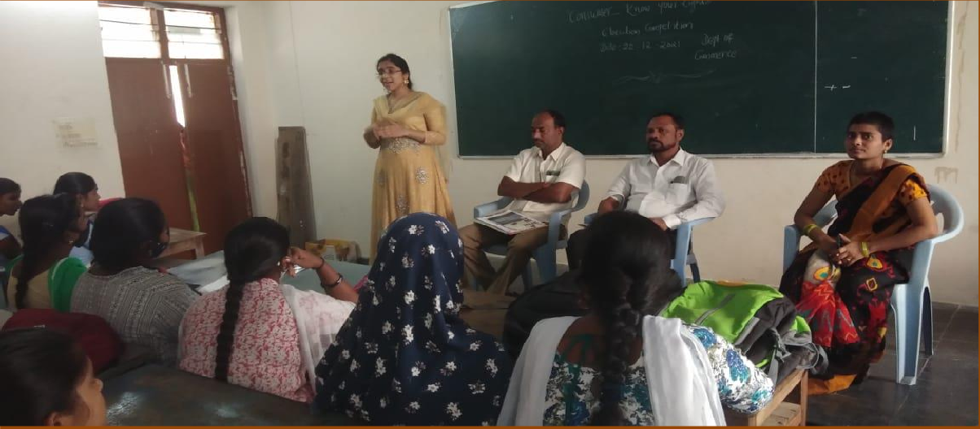

8. Developing the soft skills and Communicative skills for first year students

